NATIONAL INSTITUTE OF TECHNOLOGY, RAIPUR
APPLICATION FOR APPROVAL UNDER CPDA
(FOR ATTENDING EVENT/CONFERENCE (NATIONAL/INTERNATIONAL)/SEMINAR/WORKSHOP/TRAINING PROGRAMME)
PART A: GENERAL INFORMATION

- Name and Designation of the applicant:
- Name of the Department :
- Nature of Appointment :

Permanent/On Probation

- Sex : Male/Female
- (a) Block year of CPDA : 2021-2024
  - CPDA allocated for the current year : 1 Lac.
  - CPDA carried over from last year :
  - Total CPDA available (b+c) :
  - Amount already claimed/approved/obtained from the CPDA in the current financial year:
  - Net CPDA available (d-e) :
- Amount requested in this application :

PART B: GENERAL INFORMATION
- (a) Name of event/conference/seminar/workshop/training programme.

  - Theme :
  - Venue : City : Country :
  - Dates from

to

  - Nature of conference/symposium/seminar National ฀ International ฀
  - Details of organizer

- Purpose of visit
- Chairing the session
- Invited talk/delivering plenary lecture/keynote speech
- Oral presentation
- Poster presentation
- Any other

- Have you attended any conference/event in the past and current semester funded by NIT Raipur Yes/No.

(If yes, provide details) :
_ Contd..2..

::2::

10. | Details of paper
 | - Number of papers to be presented  - Title of paper to be presented (attach copy of paper) | :  :

- Nature of the paper (Single/co-authored) :
- Co-authors name, address, designation and highest qualification.

- NOC from co-author obtained (Yes/No)

- Travel Plan (from the place of work to the conference and back)
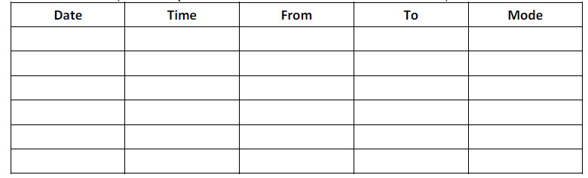

- Details of financial assistance acquired/being acquired from other funding agencies and/or event organizer:
- Details of expected expenditure
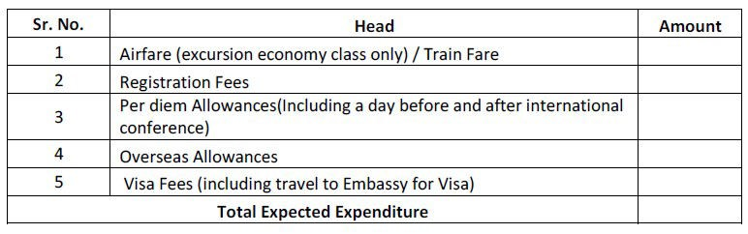
Note:-Approval/Permission for requested visit does not mean approval of requested amount.
Expenditure will be reimbursed as per institute rules/norms.
Please note that per diem allowance of 120$ is allowed against Boarding, Lodging, Transportation and all other expenses for US/UK and 100$ for other countries.
- Alternate arrangements made for academic/administrative work during the absence from NIT, Raipur
- Nature and days of leave requested for stay (CL/Special Leave/EL/Vacation
Contd…3

I certify that:-
::3::

CERTIFICATE

- The details given above are correct.
- I am a regular faculty of this institute.
- If the information supplied is found to be incorrect; I will refund the entire money to NIT Raipur.
- The money received will be used for the purpose for which it is sanctioned.
- I will present the paper and share conference experience with NIT Raipur after attending the event.

(Signature of Applicant)

Joint Registrar Dean (Faculty Welfare)

Special Casual Leave Available……………………. (Sanctioned/Not Sanctioned)

Recommended/Not Recommended

(Head of the Department)

Recommended/Not Recommended

(Director)

Approved/Not Approved

(Chairman/Director)

In case of international travel and if the CPDA application is approved, then how much amount is requested as advance, Rs…………………….
(Maximum permissible amount is 75% of the approved amount)

Outstanding advance in the name of applicant Rs………………….

Deputy Registrar (F & A)

Advance amount of Rs. …………………… is approved.

(Signature of Applicant)

NOTE:
Approved/Not Approved

(Director)

- The candidate has to make a presentation before Head of the Department and all invited faculty members of the institute to share the conference/seminar/workshop/training programme experiences. A certificate to this effect signed by Head of the Department should be submitted at the time of making a claim for the reimbursement of travel support. The claim will be settled only when such certificate is enclosed.
- Leave details and work load adjustment should be verified by Head of the Department before recommendation

Enclosures:
- Announcement of the event.
- Invitation letter from the event organizer.
- Copy of accepted paper.
- NOC from co-author (if any)

